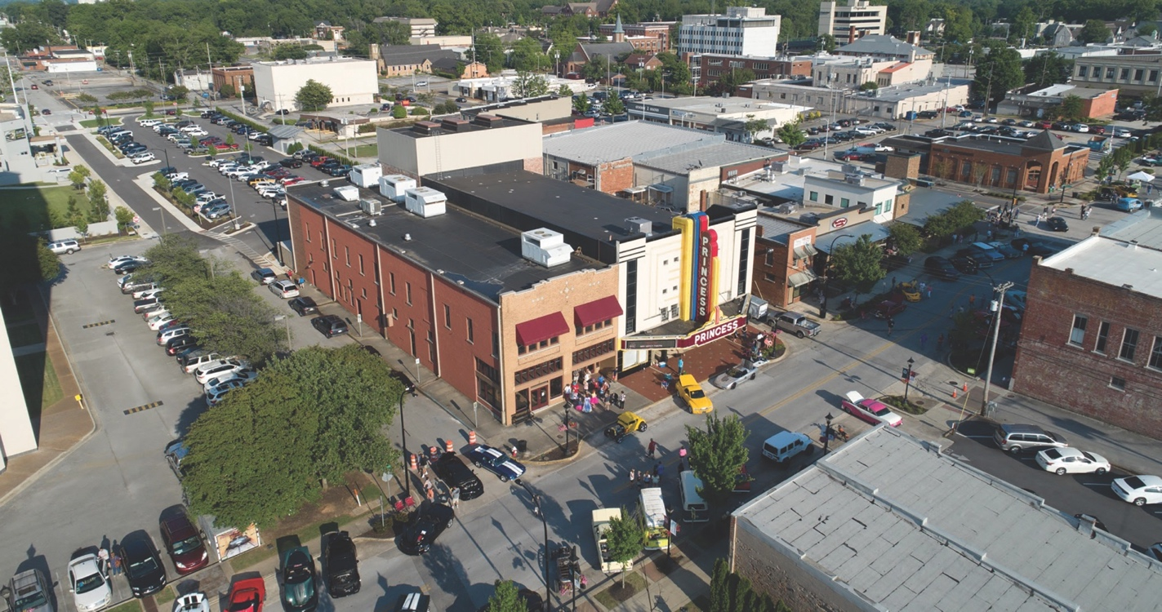

DEVELOPING DOWNTOWN DECATUR
Building on the Momentum
2020-2025 Strategic Plan

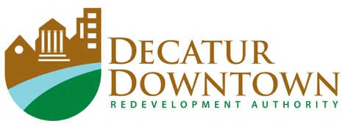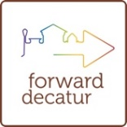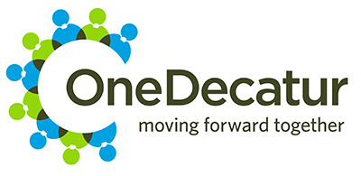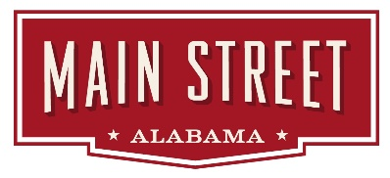

INTRODUCTION

The Decatur Downtown Redevelopment Authority (DDRA) has, over the years, partnered with leadership in government, corporate entities, foundations, and individuals to create an all-encompassing momentum driving progress in the downtown area. The accomplishments these partners have achieved have been significant and have truly transformed Downtown Decatur into a destination and attractive investment opportunity. The list of partners for the Strategic Plan for 2020-2025 continues to grow with the introduction of the One Decatur Comprehensive Plan and how it applies to the Downtown area.

Some key milestones include:
- The Cook Museum of Natural Science
- The Alabama Center for the Arts
- The Historic Depot and Railroad Museum
- Development of 30+ modern loft apartments
- Multiple pocket parks and streetscape projects
- Over $85 million in direct investment and development

The One Decatur plan is the voice of the people of Decatur, and closely aligns with the mission of the DDRA. Decatur is a Main Street Alabama designated city and all areas of promotion and development will meet the Main Street set of criteria. The input of young professionals has been integral to the development of this plan as their perception of what makes the community attractive and viable is important to the mission. Within that, the DDRA will engage in an extensive campaign to promote residential availability in the downtown area, in response to the potential influx generated by the Mazda Toyota development.
Learn more about how Downtown Decatur, Alabama has grown and developed at www.DecaturDowntown.org.

OUR HIGHEST PRIORITIES FOR DOWNTOWN DECATUR
The DDRA has two project areas selected as the highest priority and has four areas of focus that will round out the overall plan.

Beautification of the 6th Avenue Gateway
between the river bridge and Delano Park

The development of
Downtown Commons

OUR FOUR AREAS OF FOCUS
FOR CONTINUED DEVELOPMENT OF DOWNTOWN DECATUR

FOCUS AREA 1
Improving Ease of Use, Movement, and Aesthetics of
City Entries and Connectors
The first area of focus encompasses many pieces of the overall plan that are already in place. The next steps will be to ensure that entries and connectors are adequate to support the ease of use, movement and aesthetics of this area.

Overall Objectives for City Entries and Connectors
Improve overall aesthetics by moving power underground
Create more visible and attractive signage making walking trails, biking trails and parking easily identifiable
Fill in and repair sidewalks creating a continuous pedestrian friendly connection
Install additional landscaping and trees with the use of circles and squares instead of slabs of concrete, creating a softer look and cooler feel in the midst of asphalt and concrete
Light the landscaping causeway and at Wilson and 6th Avenue by the Doubletree Hotel
Light the river bridge coming in to 6th Avenue

Objectives for Specific City Entries and Connectors

6th Avenue Gateway into the City
- Develop a new Visitors Center (Tourism) close to the vicinity of the Chamber and a visible home for the Tourism group
- Create a museum-style information area within the center for maps, lists of activities, and events

Albany/6th Avenue Connector
- Install high quality and safe pedestrian crossings
- Connect Albany pedestrian traffic to the downtown area from Delano Park to downtown

2nd Avenue and Bank Street Connection
- Promote the connection of 2nd and Bank on Lee Street by working on in-fill in that area, while retaining the character of existing neighborhoods
- Consider moving the Farmers Market from 1st Avenue to the south side of Lee Street, potentially redeveloping the current site and the surrounding areas into an event-oriented day/night market and entertainment area
- Repurpose the old McClary Tire property for mixed use by having a small winter market inside as well as an artist’s market and dining opportunities

Lee Street/6th Avenue Connector
- Highlight the Lee Street entry to downtown with a significant architectural designator
- Landscape the front of Lucky’s parking lot in conjunction with facilitating the redevelopment of the overall site
- Clean up and sod the Express Oil property as preparation for future development

4th Avenue Development
- Explore the current interest in development of several properties on and near 4th Avenue
- Promote the development of the area between 6th and 2nd Avenues
- Create an Innovation District
- Continue plans for mixed use/residential in this area

Mode of Public Transportation as a Connector in Downtown
- Establish connections to border areas and parking areas
- Add transportation connecting Gordon Drive to Church Street with stops throughout Downtown
- Work with NARCOG to explore a trolley system

Parking
- Continue to review public parking to be sure it is meeting our needs now, and in the future
- Assist with development and redevelopment in finding creative ways of placing structures to create room for private parking on site
- Facilitate the analysis of the existing public parking lots to be developed into public-private partnerships, which would add apartment residential in combination with expansion of the public parking through an accompanying deck

FOCUS AREA 2
Major Development Properties including Downtown Commons and Other Currently Available Areas
The second area of focus incorporates parts of the plan that bring attention to the current available areas for development and identify potential development properties. This phase will also focus on furthering ongoing projects within Downtown Decatur by determining how to better improve current redevelopment strategies.

Development Strategies

Work on the addition of Opportunity Zones to encompass at least the downtown area to the river and the Commons area and work with NARCOG on the development of the existing Opportunity Zone
Collaborate with the city on the current efforts to “clean up” the city ordinances to make them easier to work with, promoting positive changes and deleting outdated and irrelevant information
Create a fund to purchase available properties to hold for development
Work with the groups that are currently investing in downtown to facilitate further growth on Bank Street and 2nd Avenue
Review feasibility of additional event space
Encourage and recruit businesses and mixed-use development utilizing existing structures for upgrade and repurposing, while taking advantage of Historic Tax Credits
Promote the development and use of Dry Creek as an outdoor recreational area that is complimentary and a companion to all property uses in the Commons including rafting, kayaking, fishing, and other outdoor activities

Additional Draws to Downtown

Branding
- Continue to support and promote the new branding for Decatur related to downtown attractions and tourism

Overall Aesthetic
- Add architectural lighting to downtown structures and bridges, including highlighting the Gordon Drive overpass structure as it relates to the potential redevelopment of the Farmers Market area
- Create outdoor and public murals, art and sculpture to create a colorful, interesting, inviting, artistic vibe

Outdoor Spaces and Exploration
- Create a Museum District/Trail by adding to what we have: Cook Museum, Railroad Depot, Morgan County Archives, Old State Bank, and Carnegie Visual Arts Center
- Develop the alley on Johnston Street between The Carriage House and the Maloney into an event and destination space

Downtown Events
- Develop an app or QR Code to share downtown information with a link to the city calendar
- Hire a permanent employee to coordinate and increase the number of outdoor activities and events in the downtown area

FOCUS AREA 3
Driving Residential & Mixed-Use Development

The third area of focus will primarily cover the residential and mixed-use development of downtown and its surrounding areas. This will include, but is not limited to, the development of student housing, residential structure, retail complexes, and a potential city center hotel.

Continue the process of developing residential and mixed-use properties and set a goal of potentially 200 new residential units
Develop student housing with completion of Phase III of the Alabama Center for the Arts
Establish and promote residential development sites in the Bank Street area
Develop a concept of a mixed-use parking deck, residential and retail complex on the county parking lot at Lee Street and 2nd Avenue
Pursue the development of a top-line hotel or boutique hotel in central downtown

FOCUS AREA 4
Riverfront Development
The fourth, and final, focus area places attention on the exterior of Downtown Decatur, aligning with strategies outlined in the city’s One Decatur plan. The goal will be to create an outdoor space for residents to participate in recreational activities while also attracting tourists.

Improve/retrofit riverfront facilities to accommodate business, recreational and tourism activities
Improve access to the riverfront by adding connectors and lighting
Add complementary businesses near the river bridge, such as restaurants, patio for artists, and other amenities
Continue to develop the Rhodes Ferry Park area with an emphasis on tying into a potential development below the river bridge to accommodate a kayak dock with a designated no wake zone
Culminate riverfront development by adding a pedestrian crossover on Highway 20 to connect the riverfront with downtown
Add lighting to the structure under the bridge

CONTACT
For questions or comments about this plan, please contact:

Rick Paler
Executive Director
Decatur Downtown Redevelopment Authority
Office: (256) 353-0075
Cell: (256) 651-2022‬‬‬‬‬‬‬‬‬‬‬
rpaler@decaturdowntown.org

Learn more about how Downtown Decatur, Alabama has grown and developed at www.DecaturDowntown.org.

